Joseph Heberle b 1844 d 1924 Haverhill IA
Birth: | Jul. 5, 1844
Death: | Mar. 29, 1924
Family links:
Spouse:
Caroline Heberle (1847 - 1932)
Burial:
Immaculate Conception Cemetery
Haverhill
Marshall County
Iowa, USA
Created by: Bobbi
Record added: Mar 21, 2011
Find A Grave Memorial# 67240348

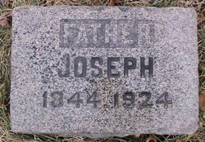
Added by: Bobbi
